A Dialogue
With
Building & Housing
and
Community Development

Directors Ed Rybka and Darryl Rush

May 11, 2011 - Saint Rocco’s - 6:00 PM

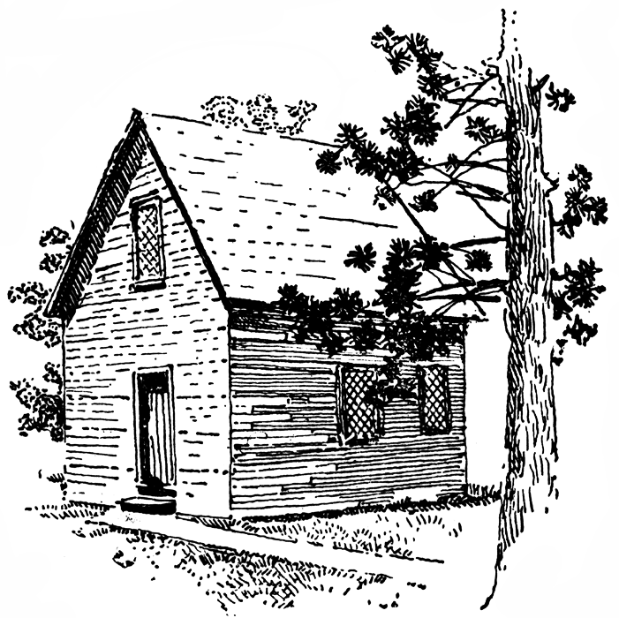
This is your chance to talk to the officials
About the Foreclosed, Abandoned and Boarded-up Houses in our community.

If you live in the Stockyard, Clark Fulton, Brooklyn Centre area and are concerned about your neighborhood, you need to attend this meeting.

Come and talk to Directors Rybka & Rush

For more information, call Kate Dupuis, SCFBC Housing Committee Chair – 216 281-0333

